Database Design Document for ABC Asset Management Fund Fact Sheet Generator
Project ID
Project Name | ABC Asset Management Fund Fact Sheet Generator
Account
Business Unit / Global Account
Project Manager
Document Version Number
Approved by | 1.0.0

Revision History
Version Number | Release Date | Description of Change/s made | Author  (Name & Role) | Reviewer  (Name & Role) | Approver  (Name & Role)
 | Mmm-DD-YY

Table of Contents
Revision History 2
1. Introduction 4
2. Database Model (ER-Diagram) 4
3. Database Environment 4
3.1 Hardware 4
3.2 Software 4
4. Database Naming Convention 4
5. Database Schema 4
< Table Name > 5
6. Design Issues and Their Resolution 5

Introduction
The purpose of the Database Design Document is to ensure that every database meets its performance requirements. This document takes into account the necessary data needed to produce a daily fund fact sheet, as well as creating a web application with access to one year worth of data.

Database Model (ER-Diagram)

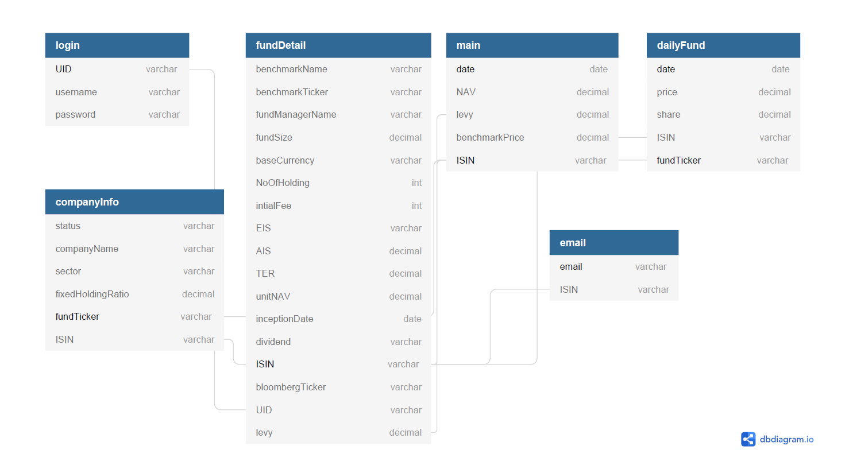

Database Environment

Hardware

4.2GB disk space, 4GB of RAM, Intel-compatible processor with 1 GHz or faster processor.

Software

SQL Server 2014 Management Studio
S.S.M.S. Ver 12.0
Supported operating systems include Windows 10, 7 and 8, Windows Server 2008 R2 and Windows Server 2012

Database Naming Convention

- Singular names for tables
- Singular names for columns
- Schema name for tables prefix (E.g.: schemeName.tableName)
- Camel casing (E.g. baseCurrency)

Database Schema

fundDetails
Field Name | Data type | Size | Constraints | Remarks
ISIN | Varchar | 50 | Primary Key
UID | Varchar | 50 | Foreign Key
levy | Varchar | 50
benchmarkName | Varchar | 50
benchmarkTicker | Varchar | 50
fundManagerName | Varchar | 50
fundSize | Decimal | 18,0
baseCurrency | Varchar | 50
noOfHolding | Int
initialFee | Int
EIS | Varchar | 50
AIS | Decimal | 18,0
TER | Decimal | 18,0
unitNAV | Decimal | 18,2
inceptionDate | Date
dividend | Varchar | 50
bloombergTicker | Varchar | 50

email
Field Name | Data type | Size | Constraints | Remarks
email | Varchar | 50 | Primary Key
ISIN | Varchar | 50 | Foreign Key

login
Field Name | Data type | Size | Constraints | Remarks
UID | Varchar | 50 | Primary Key
username | Varchar | 50
password | Varchar | 50

dailyFund
Field Name | Data type | Size | Constraints | Remarks
date | Date |  | Primary Key | Composite
fundTicker | Varchar | 50 | Primary Key | Composite
ISIN | Varchar | 50 | Foreign Key
price | Decimal | 18,0
share | Decimal | 18,0

main
Field Name | Data type | Size | Constraints | Remarks
date | Date |  | Primary Key | Composite
ISIN | Varchar | 50 | Primary Key | Composite
NAV | Decimal | 18,2 | Foreign Key
offer | Decimal | 18,2
benchmarkPrice | Decimal | 18,2

companyInfo
Field Name | Data type | Size | Constraints | Remarks
fundTicker | Varchar | 50 | Primary Key
ISIN | Varchar | 50 | Foreign Key
status | Varchar | 50
companyName | Varchar | 50
sector | Varchar | 50
fixedHoldingRatio | Decimal | 18,0

Design Issues and Their Resolution

Template Revision History (For EPEX Use Only)
Version Number | Release Date | Description of Change/s made | Author  (Name & Role) | Reviewer  (Name & Role) | Approver  (Name & Role) | QMS Release Version
1.0 | NA | Initial baseline | NA | NA | SEPG | NA
2.0 | Jun-14-11 | Assigned artifact id, version #, release date to the template and modified Information Classification label in the footer | Shreevidhya Srinivasan, PM | Radhika Seenivasakan, SEPG | Rajesh Sreekumar, SEPG | 4.2
2.1 | Nov-30-18 | Modified SEPG references to EPEX as a part of Re-Org | Prakash Palaniswamy, EPEX | Pradeep Kumar Pullathil, HEAD, EPEX | Pradeep Kumar Pullathil, HEAD, EPEX | 7.5

